Lecture 2 notes:

Data modelling Concepts

Data models:

* entity relationships model( object based )
* Relationship Data Model ( record base )

Top-down approach to DB design uses ER:

○ entities, relationships

○ attributes & constraints

● Entity

○ “thing”; artefact; object (in the Java / C++ sense); ■ noun

● Attribute

○ characteristic; property of an entity; “variable”; ■ adjective

● Relationship

○ association among entities;

● A relationship (in ER modelling) describes the connection between two or more entities (often a verb)

● A relation (in a RDB) is a table, or a set of tuples (rows)

● Both entities and relationships in the ER can map to relations in the Relational DB

● Not all relationships in the ER map to relations in the Relational DBS

● A Relation in the RDB does not always map to an Entity in the Entity-Relationship Model

Relationship:

● A Relationship is an association among one or more entities

● Relationship has a name that describes its function (usually a verb)

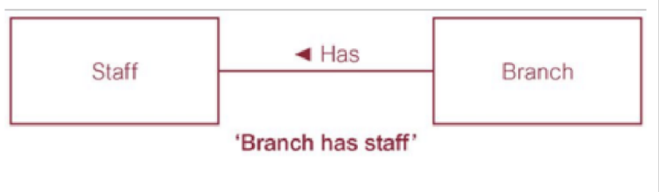

Recursive Relationship :

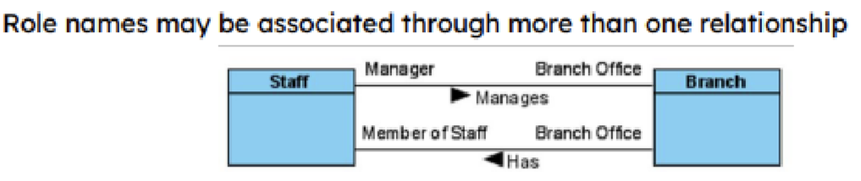A recursive relationship has the same entity participating more than once in different roles

**● Attribute domain**

**○ the set of permitted values for the corresponding attribute**

**● Simple attribute – composed of a single component**

**○ e.g., position, salary, propertyType**

**● Composite attribute – composed of multiple components**

**○ e.g., address (street, town, postcode), guestName (firstName, lastName)**

**● Single-valued attribute – holds a single value for each occurrence of an entity**

**○ e.g., postcode**

**● Multi-valued attribute – holds multiple values for each occurrence of entity type ○ e.g., branchTelNumber (more than one occurrence from the same domain)**

**● Derived attribute – attribute associated with an entity is not stored individually, but derived from other attributes (in different entities)**

**○ e.g., branchViewRate (avg number of viewings per property in any branch)**

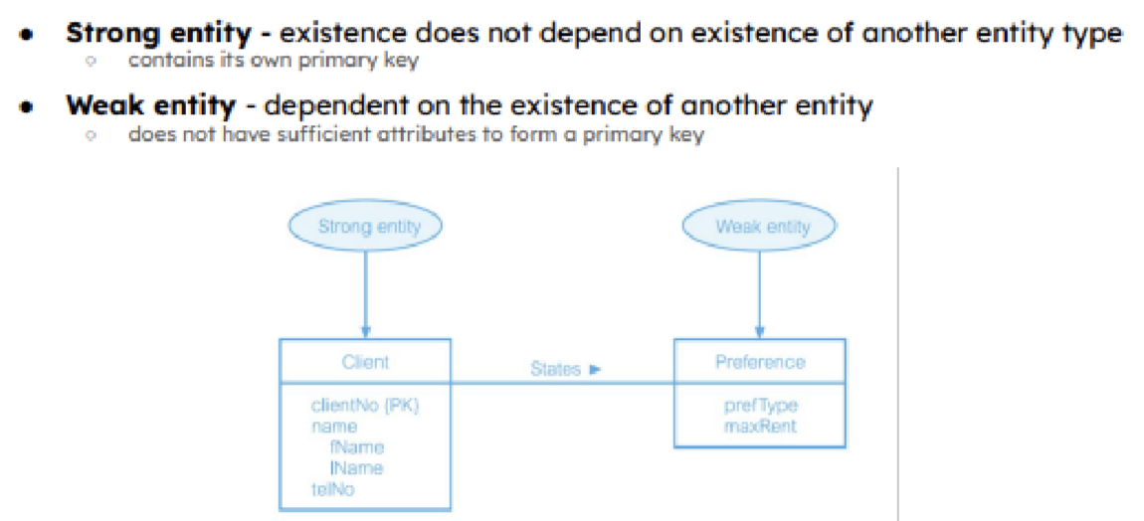

**Constraints on Entities & Relationships**

**● Multiplicity - the main constraint that exists on a relationship Defines the number of participants in a relationship**

**○ the number of instances of one entity that are associated with one instance of a related entity**

**○ represents policies (business rules) established by user / company**

**● Cardinality - the maximum number of entity occurrences of the related entity type**

**● Participation - whether all or only some entity occurrences participate in the relationship or not**

**● Multiplicity = Participation & Cardinality**

**Mutiplicity:**

* **One to one (1:1)**
* **One to many (1:*)**
* **Many to many (*:*)**
* **Multiplicity notation (maxEnd1:maxEnd2)**
* 